OROS Performance Research Report
An Autonomous Agentic Market Analyst — forward record, July 6 to July 29, 2026
JP Romero · Fordham MSAIB Capstone · prepared July 29, 2026 · simulated paper trading — educational, not financial advice

1. Headline Results (official, from the July 29 morning report)
Over 17 journaled trading sessions from a frozen July 6 baseline, three books ran the same simulated $100,000: the LIVE OROS book, rebuilt each morning by the autonomous pipeline, finished at $103,977 (+3.98%); the frozen First Portfolio (buy-and-hold of the July 6 book) finished at $100,602 (+0.60%); and SPY finished at $98,613 (−1.39%). The live book outperformed the index by 5.37 percentage points and its own frozen baseline by 3.38 points. All three lines are computed from the same journaled record; the chain is append-only and nothing is restated. (The race chart below reflects the latest journaled intraday value at the 7/29 build.)
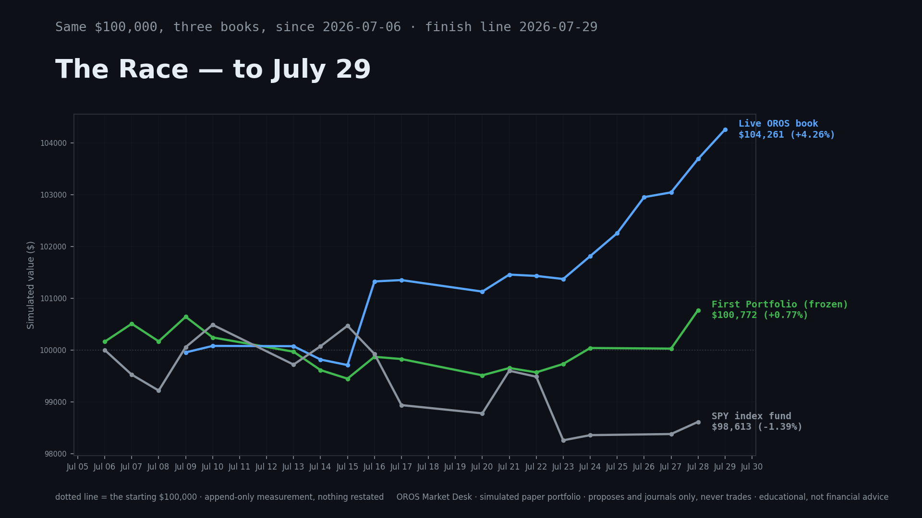

2. Methodology and Provenance
OROS is a 31-agent system: a nightly scanner grades ~500 liquid names (the OROS 500) into market stages; a regime agent reads the whole market; a construction agent selects and risk-sizes one concentrated book (1.25% risk per name inside a 6% portfolio risk wallet, sector caps, earnings blackouts); and a risk agent holds veto power. Every build is journaled as a JSON file before any surface reports it. The uniformity rule is enforced in code: the emailed report, the glance digest, the app, and both daily broadcasts read one journaled record — the add/drop diff is computed once, by the runner, and written into the record itself. Entries in the daily book are re-journaled each morning; position gains in this report and (as of 7/29) in the daily report measure from each name's FIRST consecutive entry into the book.
Data sources: SEC EDGAR XBRL and 10-K filings, Nasdaq Trader listings, Yahoo Finance daily prices (cached nightly), FRED, VADER news sentiment, StockTwits attention. Limitations stated: simulated fills at journaled prices (no slippage or commissions), 17 sessions within a single bull regime — this report claims process integrity, not statistical alpha.

3. Daily Record — the Chained Live Book
Date | Live day return | Live cumulative ($100k start) | Frozen day | SPY day
2026-07-09 | -0.05% | $99,954 | — | —
2026-07-10 | 0.13% | $100,080 | — | —
2026-07-13 | -0.01% | $100,075 | — | —
2026-07-14 | -0.26% | $99,817 | -0.36% | 0.36%
2026-07-15 | -0.11% | $99,710 | -0.17% | 0.40%
2026-07-16 | 1.62% | $101,326 | 0.42% | -0.54%
2026-07-17 | 0.03% | $101,352 | -0.04% | -0.99%
2026-07-20 | -0.22% | $101,130 | -0.31% | -0.16%
2026-07-21 | 0.32% | $101,458 | 0.14% | 0.83%
2026-07-22 | -0.03% | $101,433 | -0.08% | -0.12%
2026-07-23 | -0.06% | $101,373 | 0.16% | -1.23%
2026-07-24 | 0.44% | $101,815 | — | —
2026-07-25 | 0.44% | $102,258 | — | —
2026-07-26 | 0.68% | $102,955 | — | —
2026-07-27 | 0.09% | $103,046 | 0.38% | 0.12%
2026-07-28 | 0.63% | $103,693 | 0.66% | 0.24%
2026-07-29 | 0.55% | $104,261 | — | —
Source: data/journal/capstone_chain.json (17 entries) and data/journal/day_tally.json. Daily frozen/SPY columns begin 7/14 when the evening tally journal was introduced.

4. Every Autonomous Build — Adds and Drops (the complete log)
The 46 autonomous builds journaled since go-live. UI experiments are excluded by note-tag; diffs are mandate-aware (each build compared only to the previous build of the same mandate).
Date | Mandate | Pos. | Added | Dropped
2026-06-21 | swing_momentum | 6 | — | —
2026-06-21 | swing_momentum | 8 | ARM, ASML, CSCO, INTC, LRCX, MU, MUU, NBIS | AAPL, AMAT, AMD, ANET, NVDA, PWR
2026-06-21 | swing_momentum | 8 | KLAC | CSCO
2026-06-22 | swing_momentum | 10 | BE, CSCO, TSM | INTC
2026-06-27 | swing_momentum | 2 | MRVL | ARM, ASML, BE, CSCO, KLAC, LRCX, MUU, NBIS, TSM
2026-06-29 | swing_momentum | 9 | AAPL, AMAT, AMD, ASML, CAT, LLY, LRCX, NBIS | MRVL
2026-06-30 | swing_momentum | 12 | ALNT, BPOP, CVS, DGII, DRH, EZPW, FCEL, FFBC, MKSI, MYRG, NESR | AAPL, AMAT, AMD, ASML, CAT, LLY, LRCX, NBIS
2026-06-30 | swing_momentum | 12 | EWTX, ICHR, MTZ | DGII, DRH, MU
2026-07-01 | swing_momentum | 12 | COHU, MU | ALNT, MTZ
2026-07-02 | swing_momentum | 12 | CGNX, DGII, ECPG | BPOP, COHU, CVS
2026-07-03 | swing_momentum | 12 | ATEX, BPOP | EWTX, ICHR
2026-07-04 | swing_momentum | 12 | CATY, EWTX | BPOP, MU
2026-07-04 | swing_momentum | 12 | AAL, ANAB, ASTH, BPOP, CAKE, CVS, LLY | EWTX, EZPW, FCEL, FFBC, MKSI, MYRG, NESR
2026-07-06 | swing_momentum | 12 | ALMS, ANET, BATRK, BCRX, BOKF, CSX, DE, EBAY, SPG | AAL, ANAB, ASTH, ATEX, CAKE, CGNX, CVS, DGII, ECPG
2026-07-07 | swing_momentum | 12 | AEP, MET, PSA, TSM | BCRX, BOKF, CSX, DE
2026-07-07 | swing_momentum | 12 | ARWR, BEAM, COKE, CSX, MO, SBUX | AEP, ALMS, ANET, LLY, SPG, TSM
2026-07-08 | swing_momentum | 12 | AAPL, ANET, LIN, LLY, UPS | ARWR, BPOP, CATY, COKE, SBUX
2026-07-08 | swing_momentum | 12 | ANDE, ARWR, CCEP, CMPR, WELL | AAPL, ANET, BATRK, BEAM, PSA
2026-07-09 | swing_momentum | 12 | AAPU, BAC, BPOP, CART, JNJ, KRE, PM | ANDE, ARWR, CCEP, CMPR, LIN, MO, UPS
2026-07-09 | swing_momentum | 12 | ARWR, BATRK, BEAM, CCEP, CMPR, KO, UPS | AAPU, CART, CSX, EBAY, JNJ, KRE, PM
2026-07-10 | swing_momentum | 12 | AAPU, ASND, BCRX, CSX, EBC, JNJ, KRE, SBUX | ARWR, BAC, BATRK, BEAM, CMPR, LLY, UPS, WELL
2026-07-10 | swing_momentum | 12 | CMPR, EBAY, LIN | AAPU, JNJ, KO
2026-07-13 | swing_momentum | 12 | AAPL, CGON, PM, WELL, XBI | ASND, BCRX, CMPR, LIN, SBUX
2026-07-13 | swing_momentum | 12 | ANET, BATRK, CMPR | EBC, PM, XBI
2026-07-14 | swing_momentum | 12 | AAPU, EXEL, LLYVA, LLYVK, MTCH, NBIX, NESR, NTRS | ANET, BATRK, CCEP, CGON, CMPR, CSX, KRE, WELL
2026-07-14 | swing_momentum | 12 | BATRK, BOKF, CCEP, CGON, CSX, KRE, SBUX, WELL | EBAY, EXEL, LLYVA, LLYVK, MTCH, NBIX, NESR, NTRS
2026-07-15 | swing_momentum | 12 | AMLX, ANET, USB, XBI | AAPU, BATRK, BOKF, KRE
2026-07-16 | swing_momentum | 12 | FFBC, HST, KBWB, KSPI, MTCH, NBIX, NTRS | AMLX, ANET, CCEP, CGON, MET, USB, XBI
2026-07-16 | swing_momentum | 12 | CASY, CATY, KO, MET, MO, UNP, XLE | FFBC, HST, KBWB, KSPI, MTCH, NBIX, NTRS
2026-07-17 | swing_momentum | 12 | EBC, KRE, MTCH, NTRS, TGT | CASY, KO, MET, UNP, XLE
2026-07-17 | swing_momentum | 12 | CACC, CASY, MET, NEE | CATY, EBC, MTCH, NTRS
2026-07-20 | swing_momentum | 12 | COLB, EBC, KBWB, LAMR, MNST, NTRS, SPG, USB | AAPL, BPOP, CACC, CASY, CSX, MET, NEE, TGT
2026-07-20 | swing_momentum | 12 | AAPL, BOKF, BPOP, CASY, CATY, CSX, TGT | COLB, EBC, KBWB, LAMR, MNST, NTRS, USB
2026-07-21 | swing_momentum | 12 | DXPE, KBWB, LAMR, MET, MNST, MTCH, NTRS, UNP | BOKF, CASY, CATY, CSX, MO, SBUX, SPG, TGT
2026-07-21 | swing_momentum | 12 | BANR, CASY, CHRW, COLB, DRH, TGT, UPS | KBWB, KRE, LAMR, MET, MNST, MTCH, NTRS
2026-07-22 | swing_momentum | 12 | CSX, KBWB, KRE, MNST, MTCH, NTRS | BANR, CASY, CHRW, DRH, UPS, WELL
2026-07-22 | swing_momentum | 12 | BUSE, CASY, CHRD, IYT, MET, WELL | COLB, KBWB, KRE, MNST, MTCH, NTRS
2026-07-23 | swing_momentum | 12 | COLB, KBWB, KRE, LAMR, MNST, NTRS, UPS | BPOP, BUSE, CASY, CHRD, IYT, MET, WELL
2026-07-23 | swing_momentum | 12 | ANET, APA, BGC, CASY, CHRD, DRH, DRS, ECPG, NVDA, WELL, XOP | AAPL, COLB, CSX, KBWB, KRE, LAMR, MNST, NTRS, TGT, UNP, UPS
2026-07-24 | swing_momentum | 12 | CHRW, HST, HTO, KALU | APA, CHRD, ECPG, NVDA
2026-07-24 | swing_momentum | 12 | AAPL, APA, CHRD, COP, DBC, ECPG | CHRW, DRH, DXPE, HST, HTO, KALU
2026-07-24 | swing_momentum | 12 | CSX, DRH, DXPE, HST, HTO, KALU, PM, SPG, UNP | AAPL, ANET, APA, CHRD, COP, DBC, DRS, ECPG, WELL
2026-07-27 | swing_momentum | 12 | AAPL, APA, CHRD, DRS, FLR, MET, WELL | CASY, CSX, DRH, DXPE, KALU, PM, UNP
2026-07-27 | swing_momentum | 12 | AVT, CASY, MRK | HST, HTO, SPG
2026-07-28 | swing_momentum | 12 | ACGL, CCEP, COKE, CVX, DRH, MO, XLE | APA, AVT, CHRD, FLR, MRK, WELL, XOP
2026-07-29 | swing_momentum | 12 | DLR, HTO, KO, MRK, PM, UNP | AAPL, ACGL, ARWR, COKE, MET, MTCH
Source: data/journal/portfolio_YYYY-MM-DD_*.json — one file per build, each containing holdings, entries, stops, weights, the bench (excluded names with reasons), and since 7/28 the journaled diff itself.

5. The Picks Ledger and Notable Outcomes
The morning Top Pick gauntlet (fresh Stage 2 breakout + volume expansion + positive relative strength + not extended) produced picks on 6 of 17 sessions; no-pick days are published as discipline. Documented outcomes include BANR (picked 7/16, triggered up +1.9% versus its buy-stop the same day, graded publicly that evening) and repeated not-triggered days for BANR/BIIB/DBC where the buy-stop was never touched and no capital was ever at risk. On SPY's two worst sessions of the period (−0.99% on 7/17 and −1.23% on 7/23) the live book closed +0.03% and −0.06% respectively — regime-aware exposure functioning as designed. A data-integrity audit on 7/27 found the report's add/drop diff could baseline against the wrong book (48 phantom mentions across 11 reports); it was quantified, fixed the same day, and the fix is itself journaled — self-grading includes the plumbing.
Source: data/journal/picks_ledger.json, day_tally.json, the emailed Closing Bell reports, and the public YouTube record (OROS Market Desk).

6. Evidence Inventory (submitted alongside this report)
capstone_chain.json — 17 append-only daily returns of the live book · capstone_baseline.json — the frozen 7/06 First Portfolio (shares and entries) · day_tally.json — daily live/frozen/SPY comparison · picks_ledger.json — morning picks with trade plans · portfolio_*.json — all 46 autonomous build records (plus UI experiments, note-tagged) · stage_breadth.json — nightly stage census of the OROS 500 · oros500.json — universe membership · the emailed PDF reports and the public, timestamped YouTube episodes. Every number in this document resolves to one of these files.

